**Craigslist.com**

**URL**

[ [craigslist: pakistan jobs, apartments, for sale, services, community, and events](https://pakistan.craigslist.org/) ]

**Background**

**Craigslist** (stylized as **craigslist**) is a privately held American company[[5]](https://en.wikipedia.org/wiki/Craigslist#cite_note-5) operating a [classified advertisements](https://en.wikipedia.org/wiki/Classified_advertisement) website with sections devoted to jobs, housing, for sale, items wanted, services, [community service](https://en.wikipedia.org/wiki/Community_service), [gigs](https://en.wikipedia.org/wiki/Gig_worker), [résumés](https://en.wikipedia.org/wiki/R%C3%A9sum%C3%A9), and discussion forums.

[Craig Newmark](https://en.wikipedia.org/wiki/Craig_Newmark) began the service in 1995 as an email distribution list to friends, featuring local events in the [San Francisco Bay Area](https://en.wikipedia.org/wiki/San_Francisco_Bay_Area). It became a web-based service in 1996 and expanded into other classified categories. It started expanding to other U.S. and Canadian cities in 2000. In 2023 Craigslist listed seven hundred cities in 70 countries on its website and generated 560 million visits per month.[[6]](https://en.wikipedia.org/wiki/Craigslist#cite_note-6) Despite such global presence, 90% of the website visitors are from the USA.[[7]](https://en.wikipedia.org/wiki/Craigslist#cite_note-7) Nevertheless, according to [Alexa](https://en.wikipedia.org/wiki/Alexa_Internet), Craigslist was the #19 most visited website in the United States in 2022 and #16 in the World in 2023.[[8]](https://en.wikipedia.org/wiki/Craigslist#cite_note-8)

[Source: [Wikipedia](https://en.wikipedia.org/wiki/Craigslist)]

**Image**

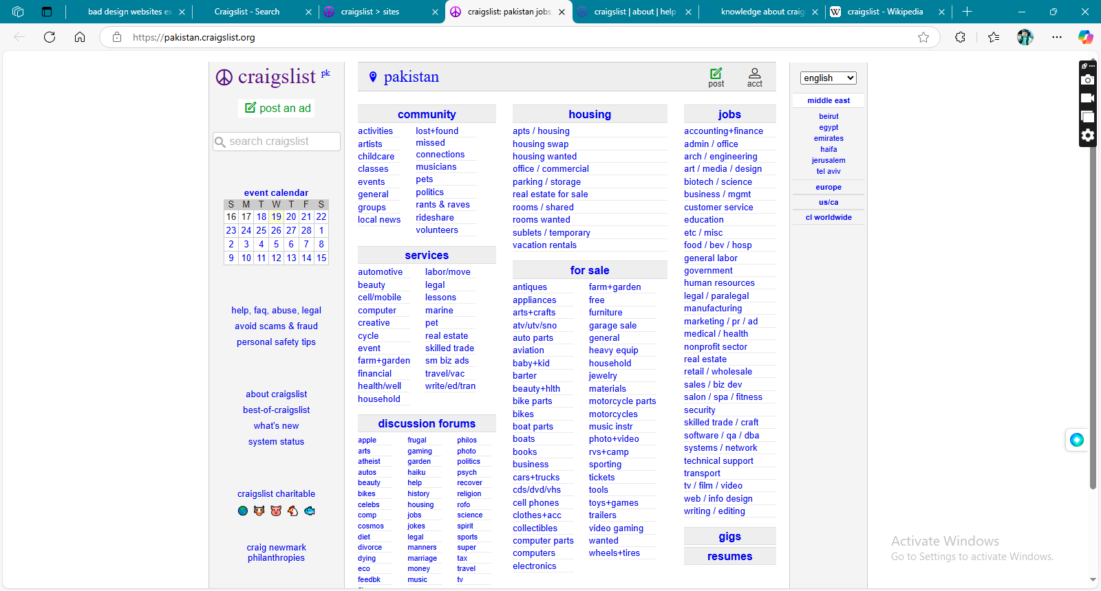

**Reason**

This is an example of bad website design because

* It does not have any good visuals.
* Does not provide good navigation and the user finds it difficult to locate what he/she needs
* The user interface does not provide anything about the functionalities of the website.
* It lacks enough images and illustrations.

**Enhancements**

Some of the enhancements we can add to this website can include:

* Add some visuals to the landing page.
* Must provide good visuals that allow users to locate their required assets without excessive searching.
* The user interface should reflect the websites’ business domain.
* We should add enough images that depicts the website as user friendly.